**Recruitment Process**

**BPMN Diagram**

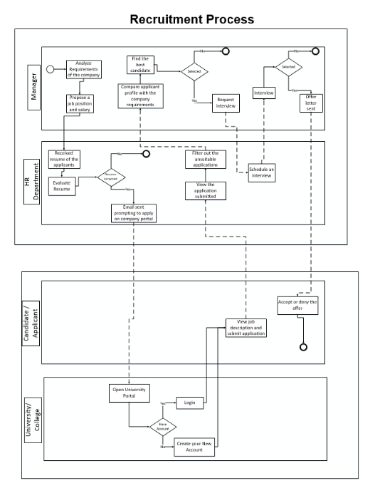

**Process Explanation:**

* The Business Process above shows a job recruitment scenario.
* Basically, there are four swim lanes and two pools. One each for the Manager, HR Department, Candidate/Applicant and the University/College respectively.
* The first pool contains the swim lanes for the Manager and the HR Department while the second pool contains the swim lanes for the Candidate/Applicant and the University.
* The process starts from the Manager. The Manager analyses the requirements for his company and thus sends a proposal to the HR Department.
* The HR Department receives the proposal and then decides if there is a need to hire a candidate or no.
* If there is a need, then, HR Department posts the requirement on the Company Website.
* When the Candidate/Applicant opens the University Portal, he sees many posts along with the job descriptions and other details.
* This can only happen if the Candidate/Applicant already has an account on the University Portal. He can login directly to view job details and description, but if not, he needs to create one and then he can view the job description.
* The HR Department then views all the applications. According to the criteria set for the position, it filters out the unsuitable applications and considers only those which may be a perfect match.
* The Manager looks at the Candidate/Applicant profile and compares it with the requirements and then selects the Candidate/Applicants for the interview.
* List of Candidate/Applicants selected for the interview is sent to the HR Department and the HR Department then schedules the interviews.
* The Candidate/Applicants are interviewed by the Manager. If the Candidate/Applicant gets selected, then he gets an offer letter from the Manager.
* Now, it is upon the Candidate/Applicant either to accept or deny the offered position.
* Hence, this is the Recruitment Process in detail.